

# South Northants Link

Appendix A

**Contents**

1. The route
   1. Central branch
   2. Northern branch
   3. Southern branch
2. Stations
   1. Northampton Central
   2. Northampton Parkway
   3. Weedon Interchange
   4. Daventry
   5. Southam
   6. Leamington Spa
   7. Towcester
   8. South Northants Parkway
   9. Brackley
   10. Banbury
3. Services/rolling stock
   1. Service frequency
   2. Rolling stock
   3. Special services
   4. Request stops



# The route

## 2a: Central branch

This is by far the simplest branch on the network, connecting Northampton Central station to Weedon Interchange, which also plans to get stopping National Rail services eventually, running as north as Liverpool and Crewe, and as south as London Euston. On the route, we will be connecting West Northampton to the heavy rail network, giving Northampton a second station finally.

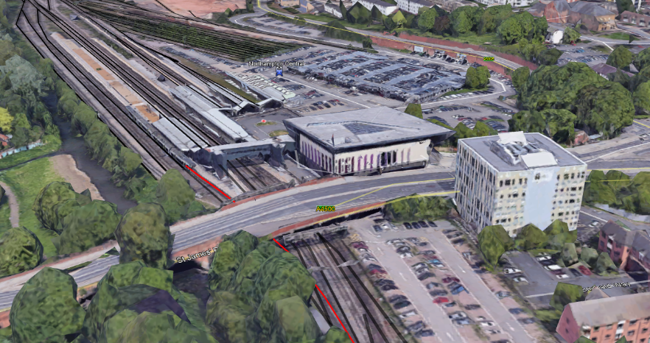Northampton Central, the existing Northampton station, acts as one of four terminuses on the network, the others being Northampton, Banbury, Leamington Spa, and of course the central terminus, Weedon Interchange, linking all the lines together.

After leaving Northampton Central as it will now be known, it follows the Northampton loop line for around 0.6mi, after detaching off to follow its own course for 7.4mi, before meeting up with the West Coast Main Line fast lines at Weedon Interchange.

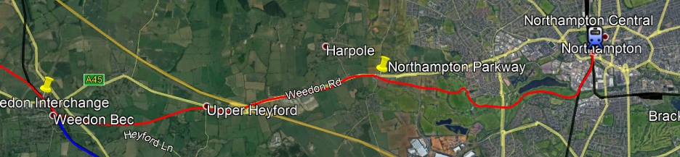

Along the route, the services will call at Northampton Parkway almost all the time, taking pressure off the new Northampton Central station, which will no question receive more passengers with it being the busiest station expected on the network, and the 3rd busiest in the entire East Midlands region currently.

Northampton Parkway will also be where services terminate if an issue arises on the line between Northampton Parkway and Northampton Central, or if Central gets too congested.

The line cuts through around 1mi of public green land on the route, such as country parks around the Upton area.

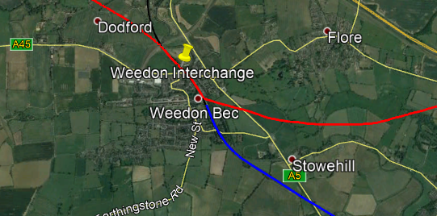The line terminates as I have said in Weedon Interchange, but direct services to Banbury and Leamington Spa all the way through to Northampton will of course still be possible.

## 2b: Northern branch

Now moving on to the Northern branch, the line that will connect Daventry, Southam, and Weedon together. Daventry is the most important town on the route, being the best example of a large town without a rail link in the UK.

The line starts out from Weedon Interchange, following the West Coast Main Line for around 0.4mi, before following the old Weedon to Marton Junction (Leamington Spa) alignment through Dodford, which was shut by Beeching in the era, before arriving in South East Daventry. The line avoids any buildings in the High March Industrial Estate in the South of the town, and after around 0.9mi from the estate, arrives at Daventry station, which we expect to be one of the busiest stations on the network.

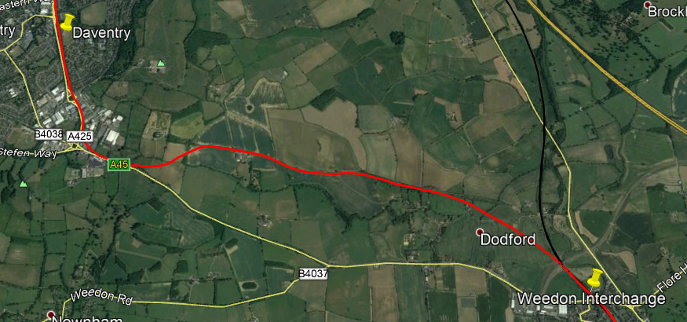

Visible on the map is the part of the branch between Weedon Interchange and Daventry station. At the South East of the town of Daventry, visible is High March Industrial Estate, which we avoided. Within the village of Dodford, no damage is created, we avoid the entire village, with a population of 209. On this branch of the line, little to no damage is incurred.

Now moving on to Daventry – Southam. This part of the line also uses the Weedon – Marton disused line mostly. For reference, see below. The line in light blue is the Great Central Main Line (closed), and the purple from Weedon to Long Itchington is the Weedon – Marton line. The line going up to Long Buckby Wharf on the East of the photo is the current West Coast Main Line.

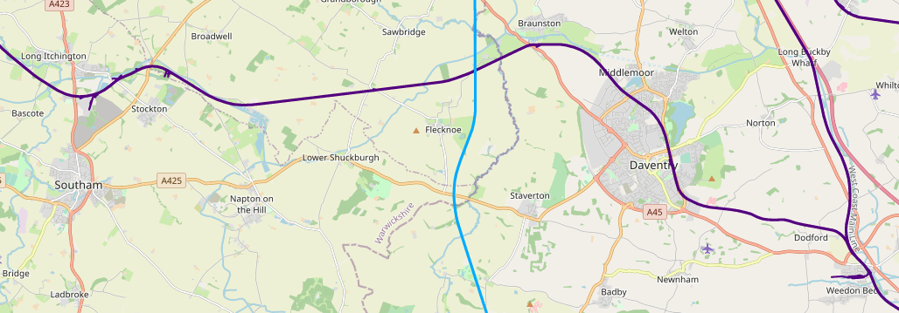

For now, back to 2021. As I mentioned, the line leaves Daventry Northbound towards Braunston, following the old alignment out. Within 2.7 mi, we are at the old Braunston station, however the current population of Braunston does not suffice to build a stop on a heavy rail network in the village, especially when Daventry is so close. However, on the light rail version of South Northants Link, this does exist.

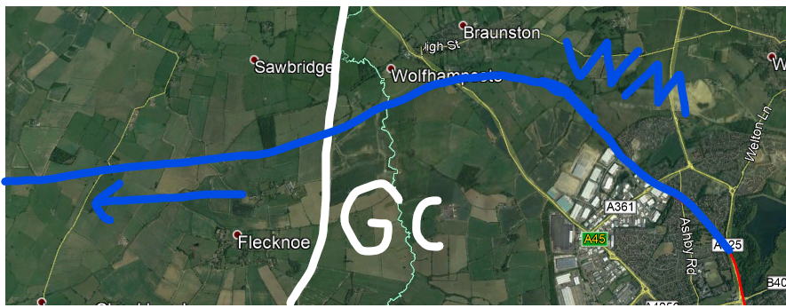

Visible on the below image is the Great Central Main Line, marked GC, in white, and the Weedon – Marton alignment, marked as WM, in dark blue.

After 5.5mi from Braunston, we disconnect from the old alignment and start on our own course to make our way to Southam, which never had it’s own railway station in the past, only served by Long Itchington’s, on the Weedon - Marton line.

3mi after we disconnect from the old alignment at Calcutt, Weedon – Marton, we arrive in Southam. The station is around 0.4mi from the centre of the town, to avoid any damage in the town.

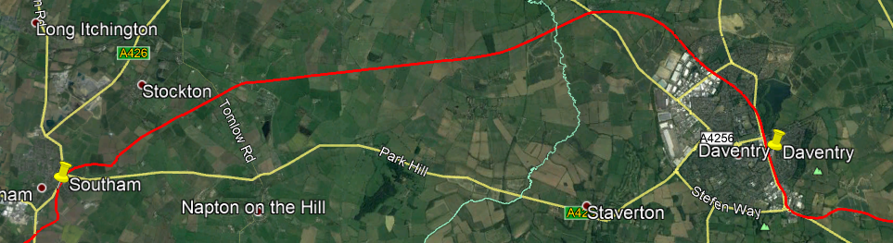

Now a reflection on the Daventry to Southam route. No major damage was incurred, something that will stay the same on the vast majority of the route. Most of this part of the branch was old alignment, however, around 3.5mi was not, but of 5.5mi being disused, that is a rather good percentage. Sometimes its good to try new things, too.

Now, last part of this branch, Southam to Leamington Spa, very straightforward. No disused track is used on this part of the branch, but it is only 3.5mi until we link onto the Chiltern Main Line in the direction of Royal Leamington Spa. After 5.5mi of running on the Chiltern Main Line, after connecting near Harbury, we arrive at Royal Leamington Spa station, where a few upgrades will need to take place.

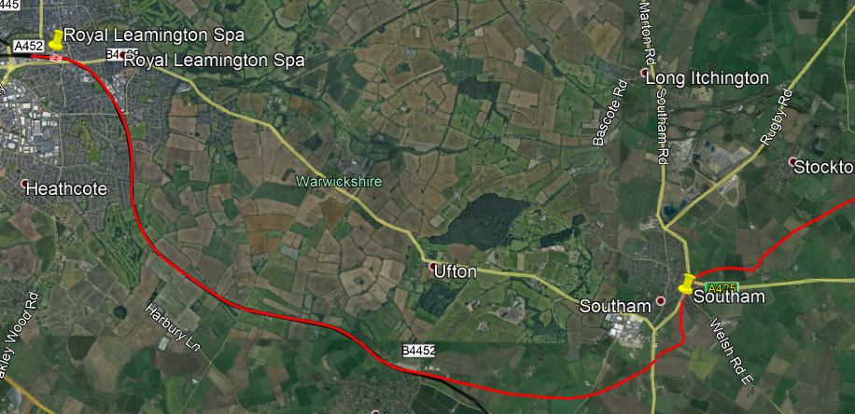

Yet again, on this part of the branch, no major damage occurs, making the Northern branch major damage free! This part of the branch doesn’t use any old alignment, but 5.5mi out of 8.5mi is on the Chiltern Main Line, sharing it’s infrastructure.

## 2c: Southern branch

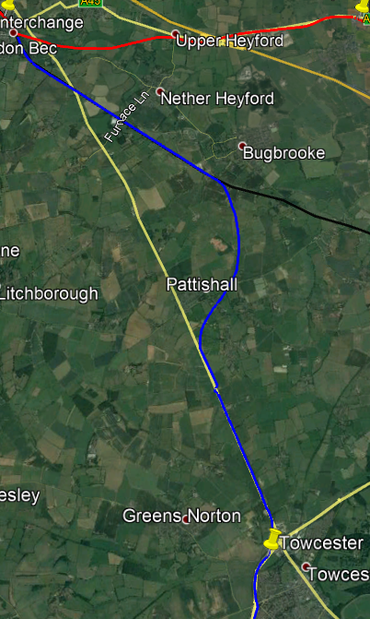

Now moving on to the Southern branch, debatably the most complicated.

First, travelling 24mi back to Weedon, we go South, following the West Coast Main Line for around 3.5mi, before disconnecting in the Bugbrooke area and going on our own course for 2mi, then we meet up with the A5, which we follow for 2.5mi, reducing damage.

After this, we meet up at Towcester, to the north of the town, around 0.8mi from the centre of the high street.

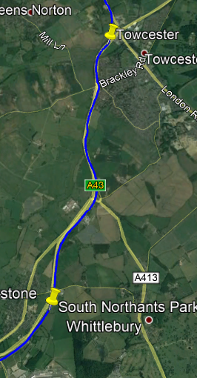Reflecting on this part of the branch, we can see still that no major damage has incurred, and that most of the journey, either the West Coast Main Line has been used, or the A5 has been followed to reduce construction challenges and destruction.

Now, we continue to South Northants Parkway, serving the Towcester suburbs, and the villages around the Silverstone Circuit, including “Silverstone Village” and Whittlebury, and of course, the Circuit itself, one of the busiest in the country. This part of the branch follows the A34 for the majority and could possibly allow a shuttle bus or slight movement of the proposed alignment to connect to Silverstone Circuit better.

Now it is full steam ahead to Brackley, with a population of 15k. We continue to follow the A43, also where the station in Brackley is. After 7.3mi from South Northants Parkway, and 11mi from Towcester, we arrive. The station is on the outskirts of the town, and a footbridge will have to be built across the A43 to connect the residents of the town to the station, as well as a new junction for road users (however, we are trying to encourage sustainable transport to the stations).

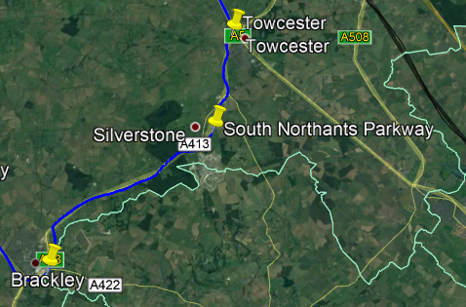On this section of the line, no damage has been incurred whatsoever either, including within Towcester, Silverstone/Whittlebury, and Towcester, which is great to see.

No old alignments were followed, unfortunately, but from Towcester to Brackley, no direct links have ever existed.

But this is where that changes. From Banbury to Brackley, we follow the old Banbury branch of the London and North Western Railway, very convenient. We then pull into Banbury station which will no question also need upgrades to take the new capacity.

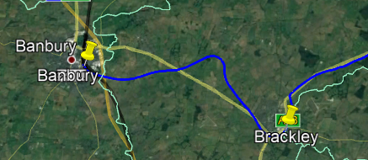



# Stations

## 3a: Northampton Central

The original station, Northampton, but with a new name to match its brand-new sibling, Northampton Parkway. A few upgrades will be needed at Northampton Central, including the following:

* Two new platforms to be built, to handle the new line.
* All platforms to be made more accessible.
* More Taxi lanes for more usage.
* Renaming the station.

As one of the 4 hub stations, with all services on the Northern, Southern and Central branches calling there, it needs to be ready for a lot of traffic. With these upgrades, we are sure Northampton Central can handle it, with Northampton Parkway there if it gets too busy. People can take a South Northants Link train to Northampton Central and catch a London Northwestern Railway WCML service to London/Crewe from this station as well.

There is not much else to say about Northampton Central, but we know this new line would change not only the station, but the rest of Northampton forever.

## 3b: Northampton Parkway

One of the most important stations on the network, acting as a buffer for Northampton Central if it gets too congested, and acting as Upton and West Northampton’s link to the railway.

The station design will be like other parkway stations in large towns such as Aylesbury Vale Parkway, see the figure below:

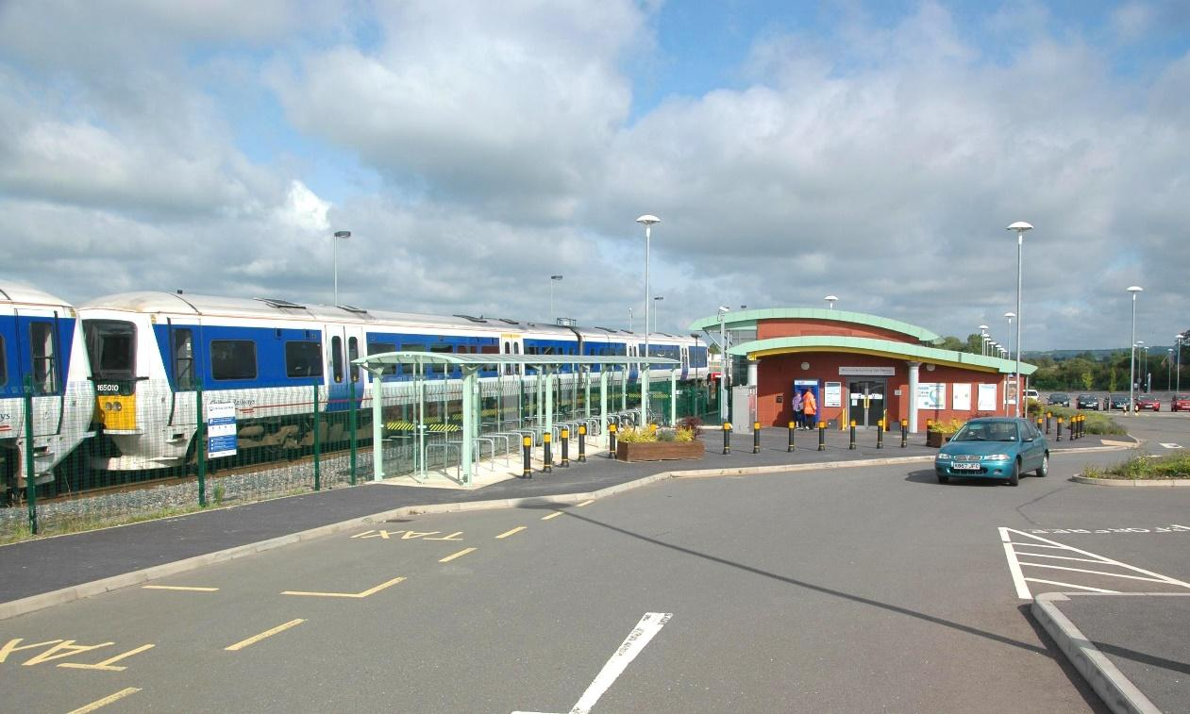

The station will have a large car park (we will be encouraging accessible means of transport to the station, so EV chargers will be implemented, to allowing a Charge + Ride service), with a small but respectable station building. The station will have 2 platforms, extendable to 4 in the future if capacity requires. It will be located just outside Upton right off an A4500 roundabout, see figure on the next page:

No other rail links will be available at the station; however, bus services are available at nearby bus stops, which will be assigned for station use. The main purpose of the station as I said, is to take congestion off Northampton Central, but to also serve West Northampton and the suburbs of Northampton.

Upton is becoming a busy place, and so is Harpole, both examples of villages/suburbs in West Northampton. They need a sustainable transport link, and this is how we will achieve it. No special services will stop at the station, including Silverstone Race services, due to the niche nature of such a service stopping at the station. However, exceptions include if Northampton Central is too congested. However, all standard timetabled services will stop at the station. See figure on the next page for precise location:

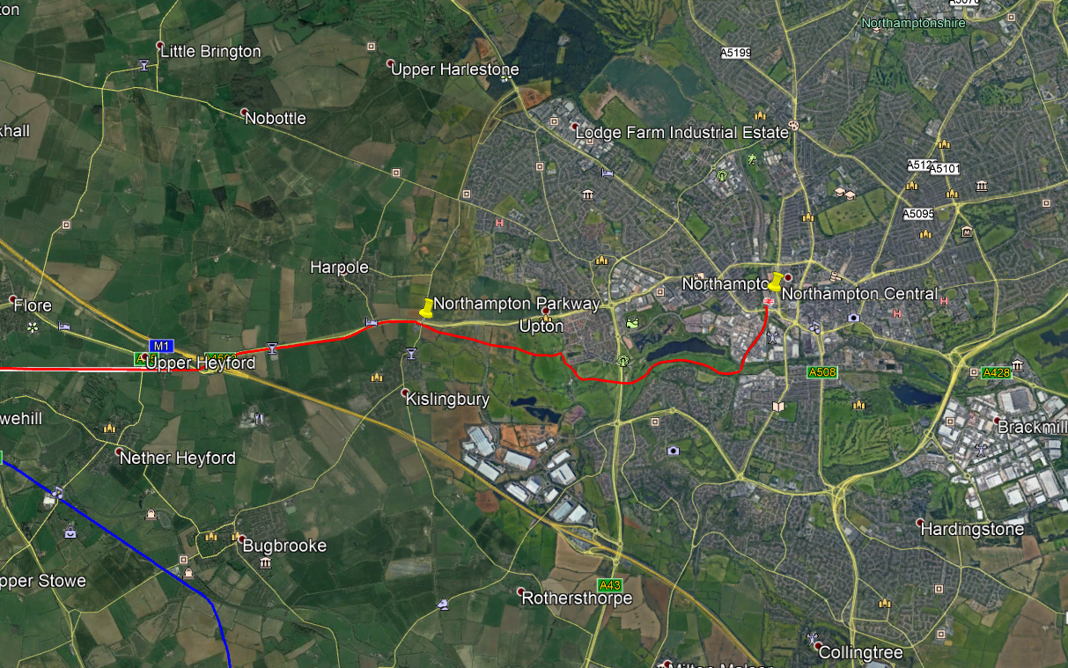

## 3c: Weedon Interchange

Weedon Interchange is the main station on the South Northants Link network, connecting the Central, Northern and Southern branches to the West Coast Main Line.

The design of the station and size will be relatively similar of Ebbsfleet International, a Highspeed station in the South East of England, see the figure below:

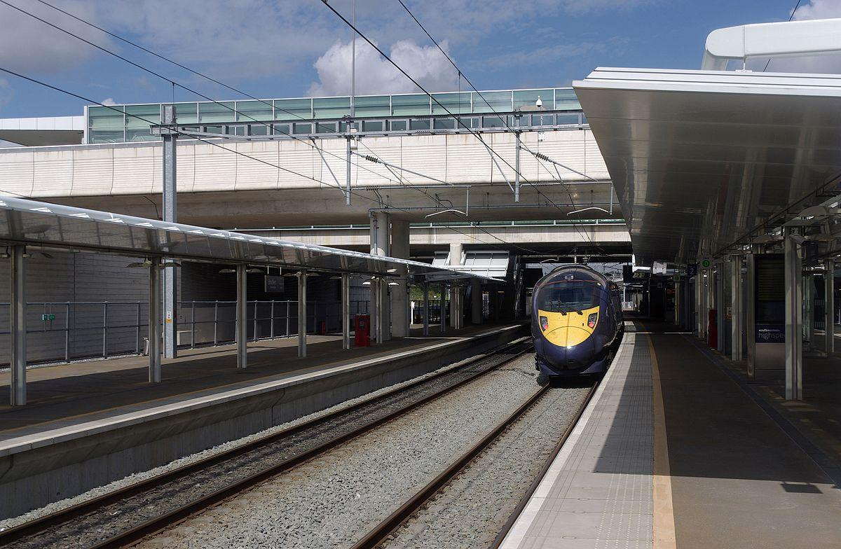

6 platforms will be in use at Weedon Interchange, 2 for stopping WCML services, 2 for non-stopping WCML services, and of course, the South Northants Link services, of which all will stop at the station, including special services. A car park will be in place at this mega-station, located either on a nearby field, or in the Heart of England pub. Buses will also have a connection to the station, with existing bus stops in the area. We will encourage sustainable transport to the station, like all of our others.

The location of the station will be in the existing area of the proposed Weedon Station by our sister project, Weedon Station Project, see the figure below:

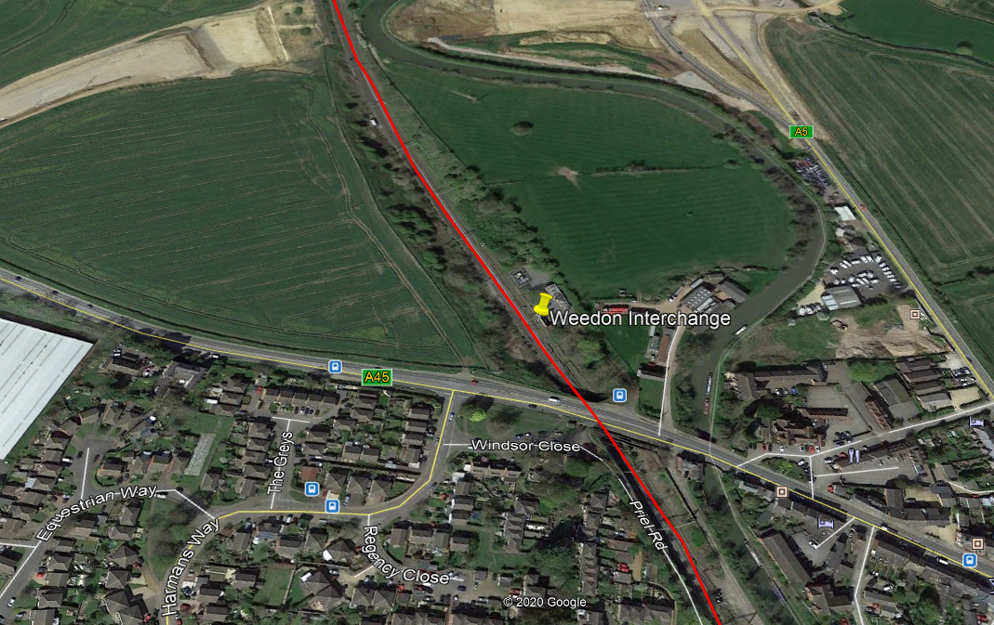

Land will have to be purchased to the West of the line, for space for the station building, a car park, and other platforms, as the East of the line has been purchased for building a new housing estate, from which will benefit from this station.

Weedon is growing at a rapid pace, and needs a connection to the National Rail network, with new infrastructure and housing projects happening in the area, and the population growing rapidly. All South Northants Link services will stop at the station, with a half-hourly London Northwestern Railway service stopping at the station, and if the operator agrees, an hourly Avanti West Coast service stopping at the station, North, and South.

## 3d: Daventry

Daventry has been disconnected from the rail network since the 1900s and is one of the largest towns in the UK not to have a railway station. As Daventry is the 6th largest town in Northamptonshire, and the second most important town in the county, according to the new Unitary, it deserves to have a large station too. Daventry’s station size and design will be comparable to Herne Bay, in the South East, see figure below:

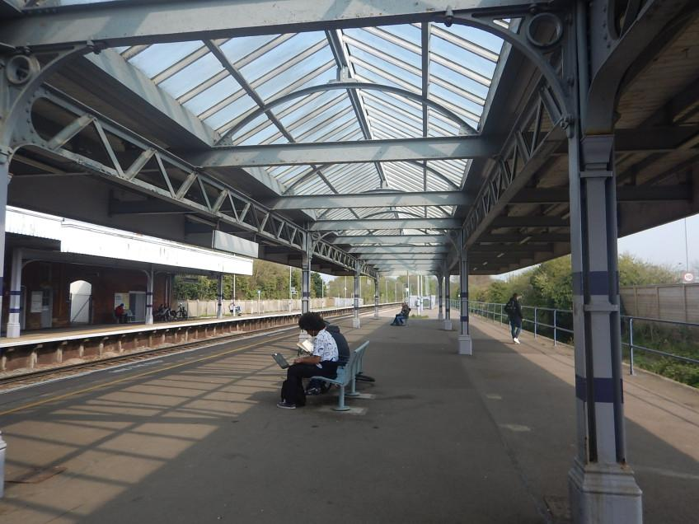

The station will have 2 platforms, extendable to 4 if capacity requires. It will be located opposite McDonalds Daventry, on the A425. It will have a large car park, but we will encourage sustainable transport to the station, and EV chargers will be in place. There is a large unoccupied field which the station will be built on, so space is not a problem, see figure on the next page:

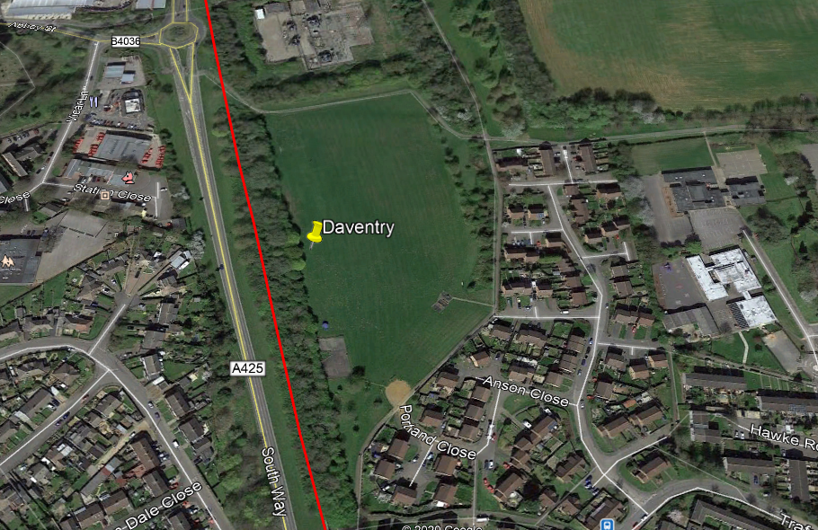

No other rail links will be available at the station; however, bus stops can be added to the station concourse, which will house the car park, ticket machines, and of course, bus lanes. No bus stops are currently available near the proposed station location.

All services will stop at the station, as no special services will run on the Northern branch line. Daventry are in dire need of a new rail link, and this will be their big moment, being able to get to London in approximately an hour, by changing at Weedon Interchange for a West Coast Main Line service.

## 3e: Southam

While I write this document, Southam is being impacted by rail lines, such as the Chiltern Main Line on the outskirts, and HS2 going right through the town. Obviously, this proposal does not want to make it worse, but instead give back to the town, as even with all these railway lines, Southam does not have a railway station.

Southam’s station will be relatively small and unmanned, but with a unique design, somewhat like Barnstaple in the South West, see figure below:

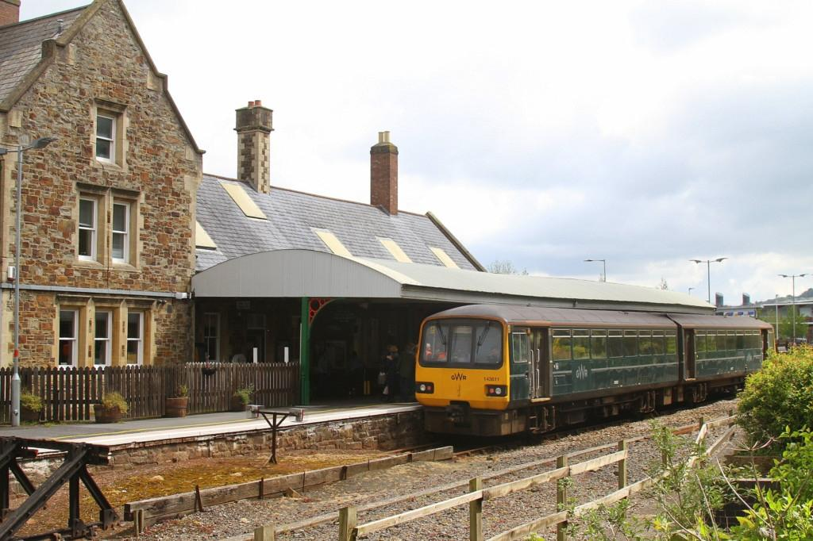

Unlike Barnstaple, the station will have 2 platforms, unlikely to be extended to 4 though, as usage of the station is expected to be lower compared to other stations on the network. A small car park, with around 8 spaces, which is standard for small stations such as Kings Sutton, will be installed, including accessible parking spots, and the EV chargers I keep talking about. Currently, no bus stops are available at the station location, so new bus stops will have to be installed on the station concourse/car park.

The station will be located on the outskirts of the town, in the East. It will only encroach on 10% of the town.

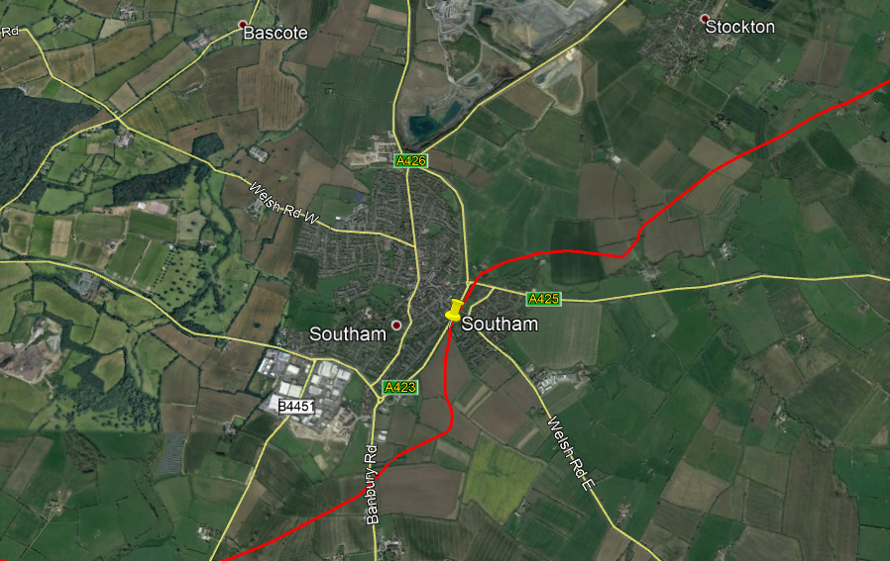

The purpose of this specific station is to give Southam, a busy town, that is growing, a link to the National Rail network, being only two stops from access to the Chiltern Main Line at Leamington Spa.

Around 90% of services will stop at the station, and all rush-hour services. No special services will stop at the station, as this is not required on the Northern branch. A station building may be implemented, but no promises are being made.

## 3f: Leamington Spa

Leamington Spa already have a railway station, with West Midlands Railway, CrossCountry and Chiltern Railways services calling at it, almost even 5 minutes. Of course, adding another line to the station will cause a lot of issues when it comes to congestion, so the following upgrades will have to be made:

* Two new platforms to be added to the station.
* Car park to be extended, to add more capacity.
  + EV chargers to be installed.

As you can see, these upgrades are limited, but not many will have to be made, but the ones that do are big ones.

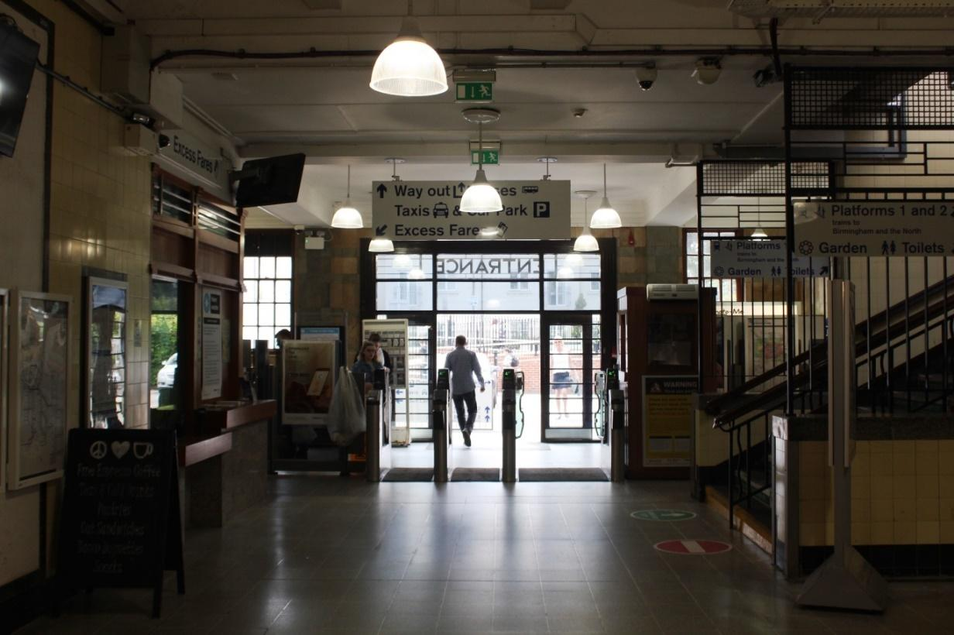

## 3g: Towcester

Now moving on to the Southern branch, Towcester has been without a rail link for around 90 years, although being 2nd largest and 1st busiest town in South Northamptonshire. Because of Towcester being so major in the county, it deserves one of the nicest train stations on the network. It will look something like Whitstable station, on the South Eastern Main Line, see figure below:

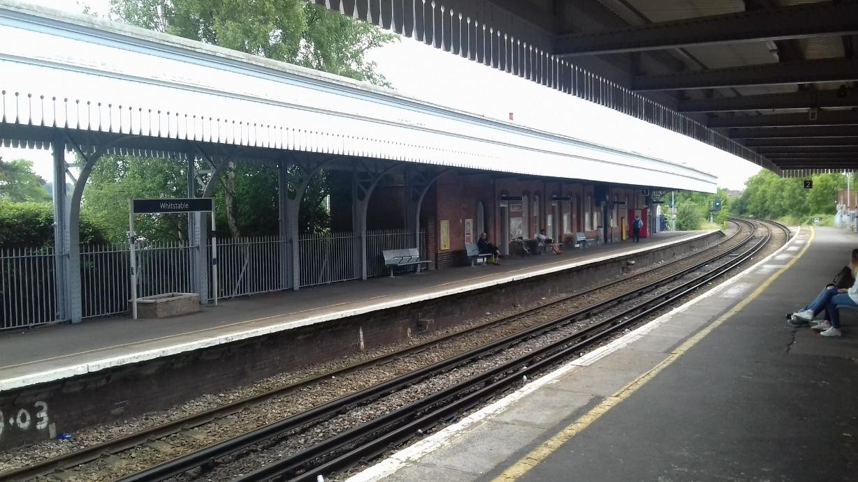

The station will have 2 platforms, extendable to 4 if capacity requires. Buses unfortunately do not currently serve the area the station would be built in, so new bus stops would have to be implemented in the concourse. Speaking of the concourse, the station will have a large car park, as there is a lot of space at the proposed location, just next to the A43, see figure on the next page. This car park will have EV chargers with our Charge + Ride service active.

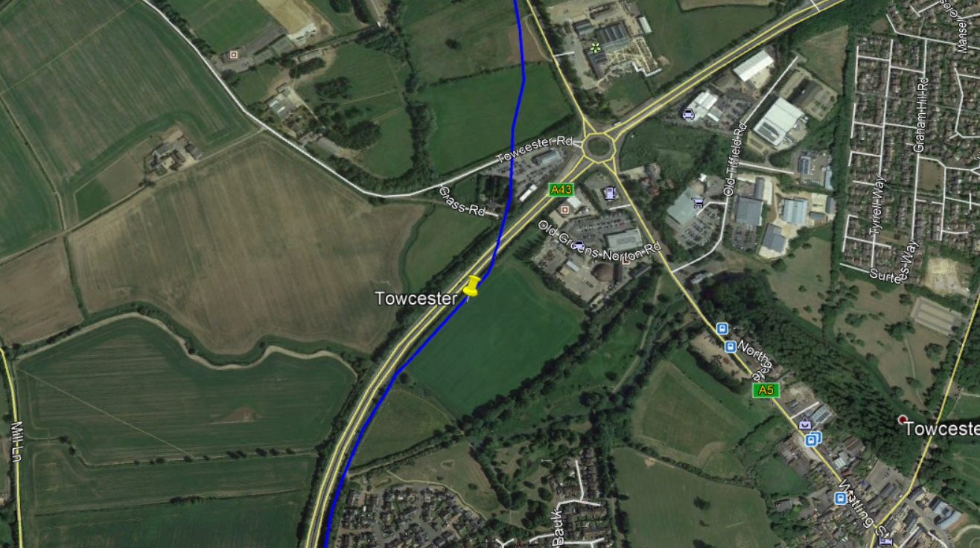

All services will stop at Towcester, including special services to South Northants Parkway. Towcester are in such a need of a link like this. The population, like all other areas on our network, is growing rapidly, and so there is the need for a link like this, among other factors.

## 3h: South Northants Parkway

South Northants Parkway is an interesting one, being almost in the middle of nowhere, until you turn around. Silverstone Circuit is one of the busiest race circuits in the country, and one of the most famous too. Although this is the case, it has weak transport links, like its village neighbours, Silverstone Village and Whittlebury. Therefore, it needs a connection on this new line, to bring in more visitors, not only to the circuit, but Northamptonshire itself.

The station will be quite big, like newly opened Worcestershire Parkway, see the figure below:

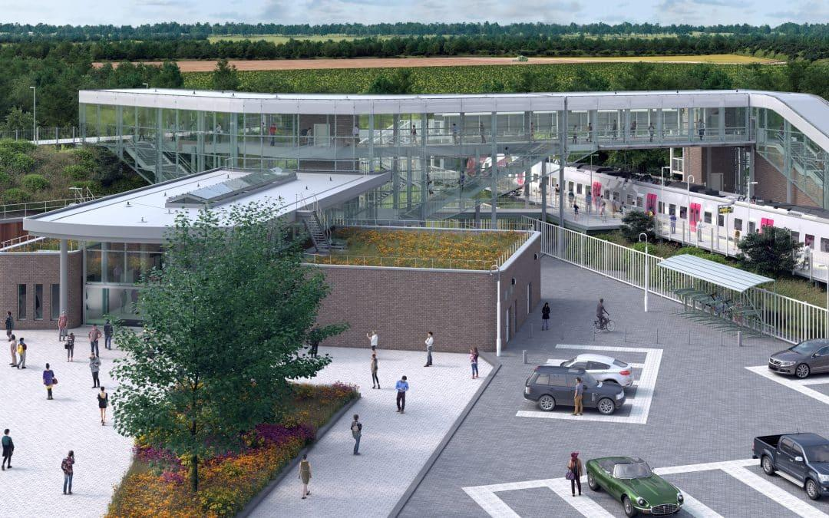

It will have 2 platforms, but unlikely to extend to 4 in the future due to expected low demand on days races are not on. However, the car park at the station will be one of the largest on our network (also with the most EV chargers!), to enable a park-and-ride (and Charge + Ride!) type facility. The station building will also be quite large, including a café type shop, maybe run locally by residents in the village.

Unfortunately, bus services are not currently available at the station location, but bus lanes will be installed in the concourse area, also enabling a shuttle service between the nearby circuit and the station.

The location of the station will not be far off the A43, and Silverstone Village, see figure below:

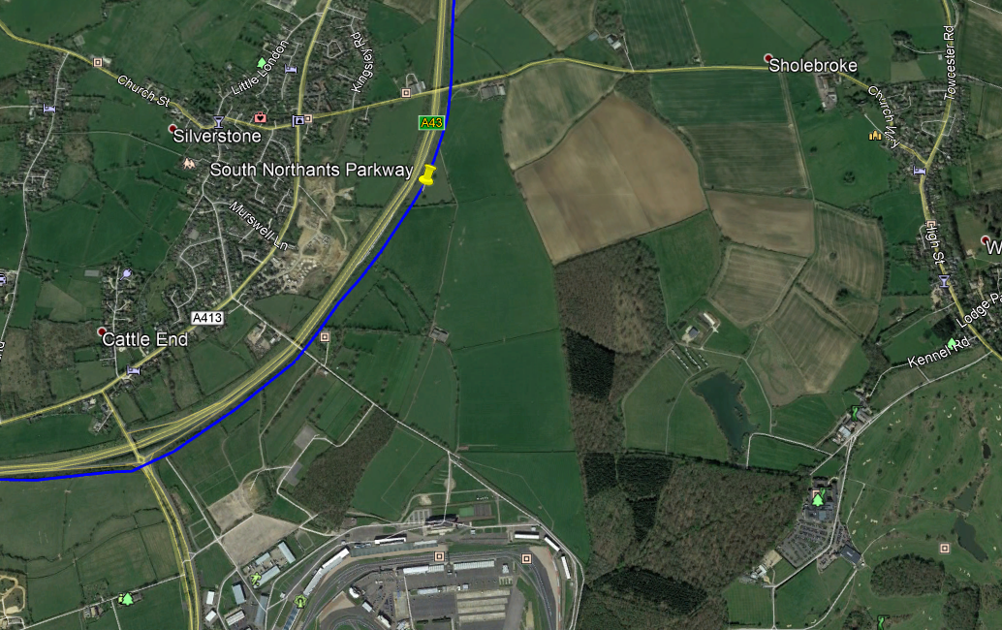

The circuit is at the bottom of the photo, and at the very right, Whittlebury, and very left, Silverstone Village. Special services will run to the station on race-days and will also include a shuttle service to the circuit if demand requires it. On standard days, around 65% of services will stop at the station, and most at rush hour for the nearby villages, so they can work in other towns

The purpose of this station is not only to enable services to the circuit, but also to enable rail links for the nearby villages such as Silverstone Village and Whittlebury, and nearby Towcester suburbs and hamlets such as Sholebroke. However, the population of the area the station will serve is only around 6000 people.

## 

## 3i: Brackley

Brackley has the largest population of any town in South Northamptonshire (2011 census) and has got terrible public transport links. That is where South Northants Link comes in. The station will be quite small, although every service passing the station will stop. The station will resemble Smethwick Rolfe Street in West Midlands, see figure below:

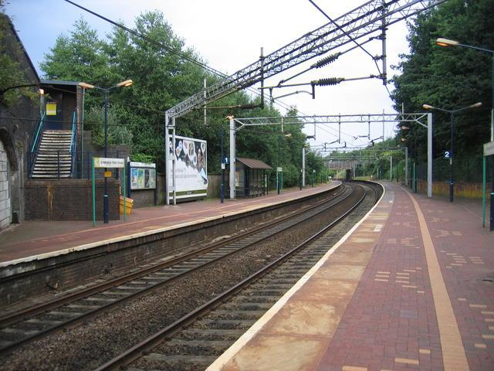

Currently, no bus stops serve this area of Brackley, so new bus stops will have to be implemented around the station. The car park will be relatively small but could be extended in future if capacity requires (EV chargers, of course!) 2 platforms will be in place at the station, but this could be doubled also if capacity requires. See the figure on the next page for context:

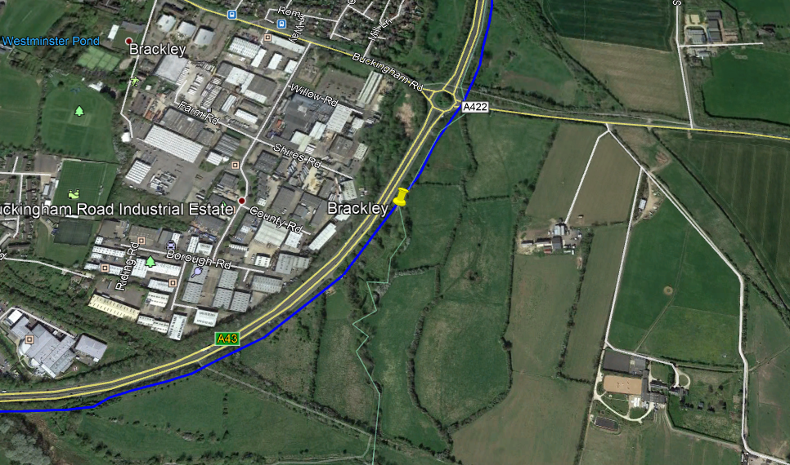

Brackley is growing at a record rate, and is bombarded by living accommodation, with terrible transport links. The SNL can change that with a brand-new railway line linking Brackley, once famous for its railways, back to the passenger network.

No special services will run as far as Brackley, so they will not make any extra stops, however all standard services on the Southern branch will stop at Brackley.

## 3j: Banbury

Banbury will be the Southern branch West terminus, where all services terminate/start from. Banbury is already a massive station, with a huge car park which is fit for capacity for years already, so the main upgrade to Banbury will only be 2 new platforms. It is quite a big job, but that is all that Banbury needs to accept this new capacity, as it is already capable of doing so. EV chargers too!

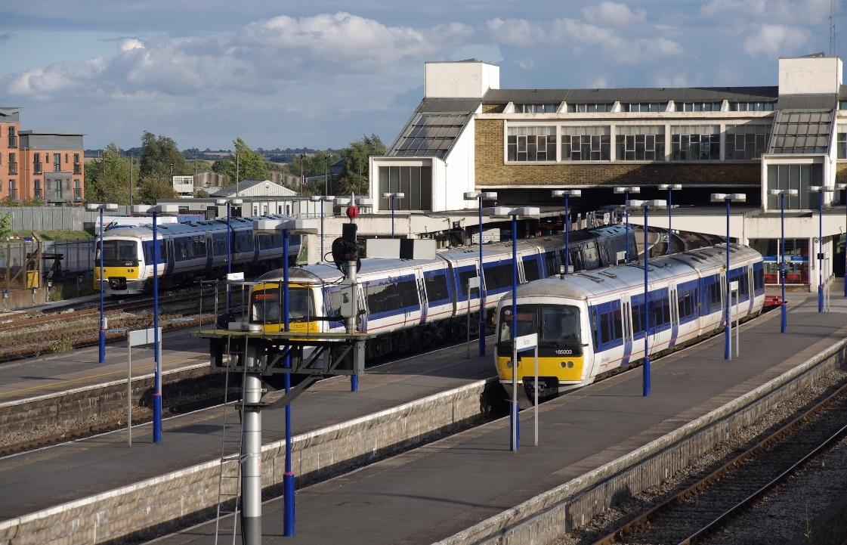



# Services/rolling stock

## 4a: Service frequency

All South Northants Link services will leave from Northampton Central, arrive at Banbury or Leamington Spa, then reverse, like a metro style system.

**Central Branch**

All services start and use the Central Branch, when arriving or leaving Northampton Central. All services on the Central branch stop at Northampton Parkway (excluding special services) and Weedon Interchange. Because of this, the Central branch has not got a specific service frequency, as its only task is to connect Northampton Central to the rest of the network.

**Northern Branch**

The Northern branch includes the stations of Weedon Interchange, Daventry, Southam and Leamington Spa. A service will run hourly on this line, leaving from Northampton Central and reversing at Leamington Spa, and stopping at all stations on the Central and Northern branch.

**Southern Branch**

The Southern branch includes the stations of Weedon Interchange, Towcester, South Northants Parkway, Brackley and Banbury. The line will get a half-hourly service leaving from Northampton Central and going back at Banbury. It will stop at Northampton Central, Parkway and Weedon Interchange on the Central branch, then switches to the Southern branch to stop at Towcester, Brackley and Banbury where it terminates (this does not include special services). South Northants Parkway will get a 2-hourly service, and of course, race special services will terminate here and reverse to Northampton Central.

## 4b: Rolling stock

New rolling stock can be released by manufacturers anytime, so it is hard to know what is best for the future, however, now, the most likely option for this line is the following:

**Electrified/battery**

Class 230 Battery EMU/DMU. This option is best, as it is already in operation on other London Northwestern Railway branch lines, such as the Marston Vale Line in Bedfordshire/Buckinghamshire. They have worked the line for more than a year and are still in operation today. They can be ordered as a standard EMU, a Diesel Multiple Unit, or Battery Electric Multiple Unit, which charges on overhead lines at stations with overhead power.

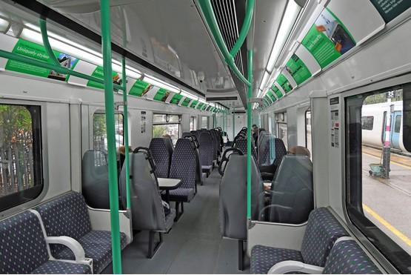

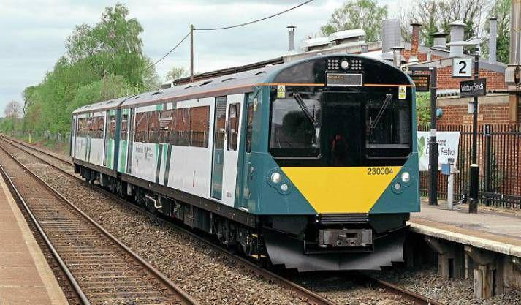

## 4c: Special services

As we all know, Silverstone Circuit is one of the busiest and most popular race circuits in the country and used by the likes of F1 and GB Racing. I am not a motorsport kind of guy, but I know the circuit needs a better link. It has not even got a bus route. The perfect way to solve this is South Northants Parkway, which will get special services on “race-days”, with longer trains that can pack more people. Trains will run to South Northants Parkway via Northampton Central, stopping at Weedon Interchange and Towcester on the way, then reversing back at South Northants Parkway to Central, to do their standard duties via the timetable.

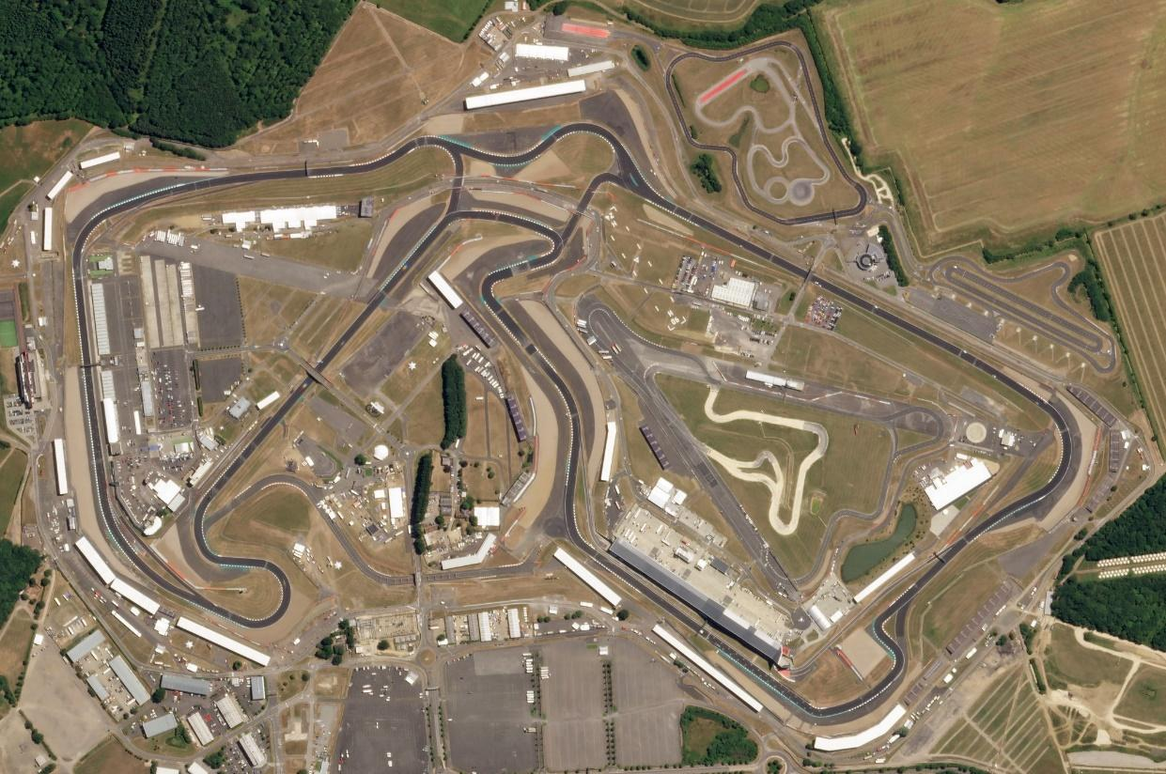

## 

## 4d: Request stops

Request stops may be implemented on the South Northants Link Line, to allow access to the line from smaller villages and hamlets without introducing congestion. Many request stops exist in England, Scotland and Wales including Wootton Wawen, Bynea, Kirkby-in-Furness and Duncraig. On this line, stations such as Braunston and Dunchurch stations could be opened as requests, allowing trains to only stop if someone wants them to, therefore not clogging up the line as much.

However, instead of holding your arm out to stop a fast-moving electric train, buttons/tablets will be introduced at the request stop station for people to click to send a message to the signaller/driver to stop their train, the next one that would be arriving at the station on that platform. (1 on each platform, 2 in total)

If someone wants to stop at a request stop during their journey, they can let the conductor on the service know to let the driver know to stop the train. Alternatively, we could develop an app to allow passengers on the service to send a message to the conductor/driver for them to stop the train at a specific stop. This has not ever been tried on an electric line in the UK, which is why a button would be implemented instead of the driver having to slow the train down on approach to the station, and so they have longer notice.

Daventry/Towcester/Brackley North/South/East/West/Parkway request stops could be built for better access to the line throughout the large town (same for Banbury, Leamington Spa and Northampton)

